**CHANDIGARH COLLEGE OF ENGINEERING & TECHNOLOGY (DEGREE WING)**



Government institute under Chandigarh (UT) Administration, affiliated to Punjab University, Chandigarh

Department of Computer Science & Engineering

**Semester**: CSE 3rd

**SUBJECT:** Data Structures Practical (CS351)

**Problem 5: Case Study of Stack and Queue**

**Submitted by: Submitted to:**

Bhavyam Dhand Dr. R.B. Patel

(CO23316) (Professor)

**Date of Practical:**23-Sep-24 **Date of Submission:**7-Oct-24

**INDEX**

|  |  |  |
| --- | --- | --- |
| S.No | Content | Page no. |
|  | Objective |  |
|  | Discussion & Modelling of Problem |  |
|  | Implementation of Code |  |
|  | Linear Search |  |
|  | Binary Search |  |
|  | Insertion Sort |  |
|  | Selection Sort |  |
|  | Bubble Sort |  |
|  | Radix Sort |  |
|  | Quick Sort |  |
|  | CODE |  |
|  | Output |  |
|  | Log File as Machine Code |  |

**CODE**

#include <iostream>

#include <string>

#include <fstream>

#include <cmath>

#include <ctime>

#include <bitset>

#include <algorithm> // For std::swap

using namespace std;

// Function to write in Log file

void LogFile(const string& event) {

    ofstream BinFile("Machine_Code_Stack.txt", ios_base::app);

    if (BinFile.is_open()) {

        for (char c : event) {

            BinFile << bitset<8>(c) << " ";

        }

        BinFile << endl;

        BinFile.close();

    }

}

// Function to Create Array

int *CreateArray(ifstream &A, int n) {

    int x, i = 0, *arr = new int[n];

    while (A >> x && i < n) {

        *(arr + i) = x;

        i++;

    }

    return arr;

}

// Function for Linear Search

int LinSearch(int *arr, int n, int x) {

    LogFile("Linear Search initiated for element: " + to_string(x));

    for (int i = 0; i < n; i++) {

        if (*(arr + i) == x) {

            LogFile("Element found at index: " + to_string(i));

            return i;

        }

    }

    LogFile("Element not found");

    return -1;

}

// Function for Binary Search

int BinSearch(int *arr, int n, int x) {

    LogFile("Binary Search initiated for element: " + to_string(x));

    if (n == 0) {

        cout << "Array Underflow!" << endl;

        return -1;

    } else {

        int low = 0, high = n - 1;

        while (low <= high) {

            int mid = (low + high) / 2;

            if (*(arr + mid) < x) {

                low = mid + 1;

            } else if (*(arr + mid) > x) {

                high = mid - 1;

            } else {

                LogFile("Element found at index: " + to_string(mid));

                return mid;

            }

        }

        LogFile("Element not found");

        cout << "Element not found!" << endl;

        return -1;

    }

}

// Function for Insertion Sort

void InsertionSort(int *arr, int n) {

    LogFile("Insertion Sort initiated");

    for (int i = 1; i < n; i++) {

        int x = *(arr + i);

        int j = i - 1;

        while (j >= 0 && *(arr + j) > x) {

            *(arr + j + 1) = *(arr + j);

            j--;

        }

        *(arr + j + 1) = x;

    }

    LogFile("Array sorted using Insertion Sort");

}

// Function for Selection Sort

void SelectionSort(int *arr, int n) {

    LogFile("Selection Sort initiated");

    for (int i = 0; i < n - 1; i++) {

        int min = i;

        for (int j = i + 1; j < n; j++) {

            if (*(arr + j) < *(arr + min))

                min = j;

        }

        if (min != i) {

            swap(*(arr + i), *(arr + min));

        }

    }

    LogFile("Array sorted using Selection Sort");

}

// Function for Bubble Sort

void BubbleSort(int *arr, int n) {

    LogFile("Bubble Sort initiated");

    for (int i = 0; i < n; i++) {

        bool swapped = false;

        for (int j = 0; j < n - 1 - i; j++) {

            if (*(arr + j) > *(arr + j + 1))

                swap(*(arr + j), *(arr + j + 1));

            swapped = true;

        }

        if (!swapped)

            break;

    }

    LogFile("Array sorted using Bubble Sort");

}

// Function for Quick Sort

void QuickSort(int *arr, int low, int high) {

    if (low < high) {

        LogFile("Quick Sort initiated");

        int pivot = *(arr + high);

        int i = low - 1;

        for (int j = low; j < high; j++) {

            if (*(arr + j) <= pivot) {

                i++;

                swap(*(arr + i), *(arr + j));

            }

        }

        swap(*(arr + i + 1), *(arr + high));

        int pi = i + 1;

        QuickSort(arr, low, pi - 1);

        QuickSort(arr, pi + 1, high);

    }

    LogFile("Array sorted using Quick Sort");

}

// Function for Radix Sort

void CountSort(int *arr, int n, int exp) {

    int *output = new int[n];

    int count[10] = {0};

    for (int i = 0; i < n; i++)

        count[(*(arr + i) / exp) % 10]++;

    for (int i = 1; i < 10; i++)

        count[i] += count[i - 1];

    for (int i = n - 1; i >= 0; i--) {

        output[count[(*(arr + i) / exp) % 10] - 1] = *(arr + i);

        count[(*(arr + i) / exp) % 10]--;

    }

    for (int i = 0; i < n; i++)

        *(arr + i) = output[i];

    delete[] output;

}

void RadixSort(int *arr, int n) {

    LogFile("Radix Sort initiated");

    int max = *max_element(arr, arr + n);

    for (int exp = 1; max / exp > 0; exp *= 10)

        CountSort(arr, n, exp);

    LogFile("Array sorted using Radix Sort");

}

int main() {

    int n, choice, x;

    cout << "Enter the size of Array: ";

    cin >> n;

    ifstream infile("array.txt");

    if (!infile.is_open()) {

        cout << "Error: Unable to open the file!" << endl;

        return -1;

    }

    int *array = CreateArray(infile, n);

    infile.close();  // Close the file after reading the data

    cout << "Original Array:" << endl;

    for (int i = 0; i < n; i++) {

        cout << *(array + i) << " ";

    }

    cout << endl;

    LogFile("Original Array: ");

    for (int i = 0; i < n; i++) {

        LogFile(to_string(*(array + i)) + " ");

    }

    ofstream OutFile("NewArray.txt");

    bool Sorted=false;

    while (Sorted!=true)

    {

        cout << "Select the Operation you want to execute on the Array:" << endl;

        cout << "1. Linear Search\n2. Binary Search\n3. Insertion Sort\n4. Bubble Sort\n5. Quick Sort\n6. Radix Sort\n7.Exit Program" << endl;

        cin >> choice;

        switch (choice) {

        case 1://Linear Search

            cout << "Select element you want to Search Linearly: "; cin >> x;

            if (LinSearch(array, n, x)!=-1)

                cout << "Element lies in Index: " << LinSearch(array, n, x) << endl;

            break;

        case 2://Binary Search

            cout << "Select element you want to Search Binarily: "; cin >> x;

            if (BinSearch(array, n, x)!=-1)

                cout << "Element lies in Index: " << BinSearch(array, n, x) << endl;

            break;

        case 3://Insertion Sort

            InsertionSort(array, n);

            cout << "Sorted Array:" << endl;

            for (int i = 0; i < n; i++) {

                cout << *(array + i) << " ";

            }

            cout << endl;

            for (int i = 0; i < n; i++) {

                OutFile << *(array + i) << " ";

            }

            OutFile << endl;

            Sorted=true;

            break;

        case 4://Bubble Sort

            BubbleSort(array, n);

            cout << "Sorted Array:" << endl;

            for (int i = 0; i < n; i++) {

                cout << *(array + i) << " ";

            }

            cout << endl;

            for (int i = 0; i < n; i++) {

                OutFile << *(array + i) << " ";

            }

            OutFile << endl;

            Sorted=true;

            break;

        case 5://Quick Sort

            QuickSort(array, 0, n - 1);

            cout << "Sorted Array using Quick Sort:" << endl;

            for (int i = 0; i < n; i++) {

                cout << *(array + i) << " ";

            }

            cout << endl;

            for (int i = 0; i < n; i++) {

                OutFile << *(array + i) << " ";

            }

            OutFile << endl;

            Sorted=true;

            break;

        case 6://Radix Sort

            RadixSort(array, n);

            cout << "Sorted Array using Radix Sort:" << endl;

            for (int i = 0; i < n; i++) {

                cout << *(array + i) << " ";

            }

            cout << endl;

            for (int i = 0; i < n; i++) {

                OutFile << *(array + i) << " ";

            }

            OutFile << endl;

            Sorted=true;

            break;

        case 7://Exit Program

            OutFile.close();

            delete[] array;

            return 0;

        default:

            cout << "Invalid choice!" << endl;

            break;

        }

    }

    OutFile.close();

    delete[] array;

    return 0;

}

**Output:**

1. Linear Search:

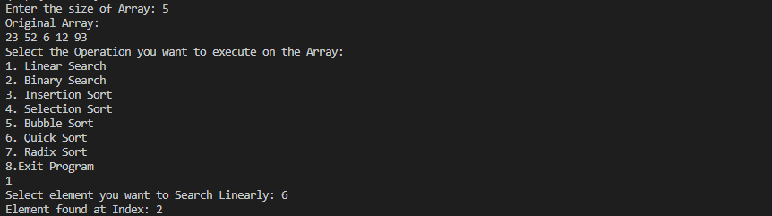

1. Binary Search:

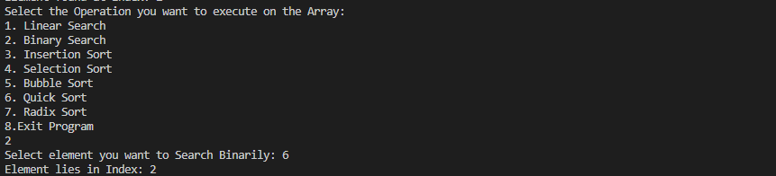

1. Insertion Sort:

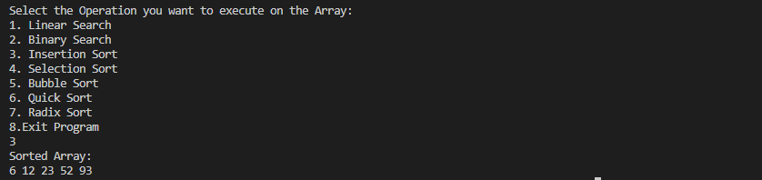

1. Selection Sort:

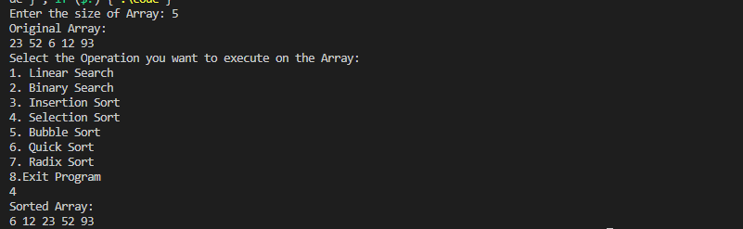

1. Bubble Sort:

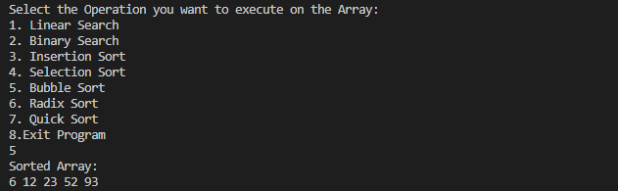

1. Radix Sort:

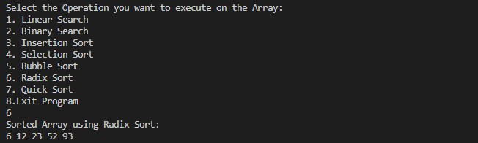

1. Quick Sort:

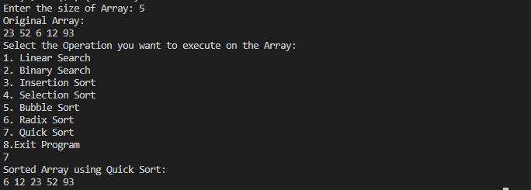

**Log File as Machine Code:**

01001111 01110010 01101001 01100111 01101001 01101110 01100001 01101100 00100000 01000001 01110010 01110010 01100001 01111001 00111010 00100000

00110010 00110011 00100000

00110101 00110010 00100000

00110110 00100000

00110001 00110010 00100000

00111001 00110011 00100000

01001100 01101001 01101110 01100101 01100001 01110010 00100000 01010011 01100101 01100001 01110010 01100011 01101000 00100000 01101001 01101110 01101001 01110100 01101001 01100001 01110100 01100101 01100100 00100000 01100110 01101111 01110010 00100000 01100101 01101100 01100101 01101101 01100101 01101110 01110100 00111010 00100000 00110110

01000101 01101100 01100101 01101101 01100101 01101110 01110100 00100000 01100110 01101111 01110101 01101110 01100100 00100000 01100001 01110100 00100000 01101001 01101110 01100100 01100101 01111000 00111010 00100000 00110010

01001100 01101001 01101110 01100101 01100001 01110010 00100000 01010011 01100101 01100001 01110010 01100011 01101000 00100000 01101001 01101110 01101001 01110100 01101001 01100001 01110100 01100101 01100100 00100000 01100110 01101111 01110010 00100000 01100101 01101100 01100101 01101101 01100101 01101110 01110100 00111010 00100000 00110110

01000101 01101100 01100101 01101101 01100101 01101110 01110100 00100000 01100110 01101111 01110101 01101110 01100100 00100000 01100001 01110100 00100000 01101001 01101110 01100100 01100101 01111000 00111010 00100000 00110010

01000010 01101001 01101110 01100001 01110010 01111001 00100000 01010011 01100101 01100001 01110010 01100011 01101000 00100000 01101001 01101110 01101001 01110100 01101001 01100001 01110100 01100101 01100100 00100000 01100110 01101111 01110010 00100000 01100101 01101100 01100101 01101101 01100101 01101110 01110100 00111010 00100000 00110100 00110011

01000101 01101100 01100101 01101101 01100101 01101110 01110100 00100000 01101110 01101111 01110100 00100000 01100110 01101111 01110101 01101110 01100100

01001001 01101110 01110011 01100101 01110010 01110100 01101001 01101111 01101110 00100000 01010011 01101111 01110010 01110100 00100000 01101001 01101110 01101001 01110100 01101001 01100001 01110100 01100101 01100100

01000001 01110010 01110010 01100001 01111001 00100000 01110011 01101111 01110010 01110100 01100101 01100100 00100000 01110101 01110011 01101001 01101110 01100111 00100000 01001001 01101110 01110011 01100101 01110010 01110100 01101001 01101111 01101110 00100000 01010011 01101111 01110010 01110100

01001111 01110010 01101001 01100111 01101001 01101110 01100001 01101100 00100000 01000001 01110010 01110010 01100001 01111001 00111010 00100000

00110010 00110011 00100000

00110101 00110010 00100000

00110110 00100000

00110001 00110010 00100000

00111001 00110011 00100000

01001001 01101110 01110011 01100101 01110010 01110100 01101001 01101111 01101110 00100000 01010011 01101111 01110010 01110100 00100000 01101001 01101110 01101001 01110100 01101001 01100001 01110100 01100101 01100100

01000001 01110010 01110010 01100001 01111001 00100000 01110011 01101111 01110010 01110100 01100101 01100100 00100000 01110101 01110011 01101001 01101110 01100111 00100000 01001001 01101110 01110011 01100101 01110010 01110100 01101001 01101111 01101110 00100000 01010011 01101111 01110010 01110100

01001111 01110010 01101001 01100111 01101001 01101110 01100001 01101100 00100000 01000001 01110010 01110010 01100001 01111001 00111010 00100000

00110010 00110011 00100000